AI Process Recovery Agent – LangGraph – Human-in-the-Loop

Project Description:
The AI Process Recovery Agent is a production-grade, end-to-end Autonomous Business Workflow Recovery System built with FastAPI, SQLAlchemy, a LangGraph agentic recovery graph, and a vanilla HTML/CSS/JavaScript "Cyber Obsidian" mission control interface. It monitors simulated e-commerce order workflows in real time — payment processing, inventory allocation, order confirmation, and delivery scheduling — and autonomously intercepts step failures, diagnoses the root cause, and self-heals the workflow back to completion.
The platform is organized around a five-step order workflow (ORDER_CREATED → PAYMENT_PROCESSING → INVENTORY_CHECK → ORDER_CONFIRMATION → DELIVERY_SCHEDULING) backed by a set of simulated business microservices for payments, inventory, orders, delivery, and notifications, each capable of having faults injected into it through a Chaos Engineering & Fault Injection Studio. When a step fails, a LangGraph state machine takes over: it performs structured Root-Cause Analysis, generates a discrete recovery plan, selects a safe predefined recovery tool from a controlled tool registry, and either executes it automatically or routes it through a Human-in-the-Loop Approval Gate when the action carries business risk (for example, product substitution or a high-value transaction above the ₹2,00,000 threshold).
A built-in Heuristic AI Reasoning Engine performs deterministic, domain-aware failure analysis and recovery planning out of the box with zero API keys required, while the same LLMService interface can be pointed at OpenAI, Gemini, or Anthropic via LangChain when an API key is supplied. Every decision the agent makes — failure detection, root-cause identification, plan creation, approval requests, tool execution, and verification — is written to an immutable Audit Log, and every workflow, failure, and recovery action is streamed live to the frontend over Server-Sent Events (SSE) with an automatic polling fallback.

Scenarios
Scenario 1: An order for an Apple MacBook Air M3 (256GB) is placed for a Bengaluru customer, but the regional fulfillment hub has zero units in stock. The workflow engine intercepts the INVENTORY_CHECK failure, and the LangGraph agent runs Root-Cause Analysis, finds an identical-cost 512GB Upgrade Edition with 18 units in stock, and stages a "replace_product" action in the Human Approval Gate. The operator reviews the AI's reasoning and impact summary and clicks Approve; the agent then updates the order, verifies warehouse allocation, and resumes the workflow to completion.
Scenario 2: A UPI / Razorpay payment for a Samsung 32-inch 4K monitor exceeds the 4000ms gateway SLA and times out. The agent detects the PAYMENT_TIMEOUT failure, classifies it as low severity and low risk, and — because no approval is required for an idempotent retry — automatically re-submits the transaction through the HDFC Bank backup gateway route. Verification confirms the funds were captured, and the Command Center's Health Ring and Agent Trace update live via the SSE stream without any operator involvement.
Scenario 3: A ₹3,49,900 MacBook Pro M3 Max order exceeds the platform's autonomous recovery delegation limit. The agent classifies the failure as HIGH_VALUE_RISK and routes it to the Human Approval Gate for a mandatory Senior Operations Director sign-off before any recovery action is executed. Meanwhile, on the Services & Chaos Studio page, the operator can independently inject a simulated HTTP 503 outage into the inventory microservice and watch the agent apply an exponential backoff retry cycle to self-heal the connection.

Technical Architecture:
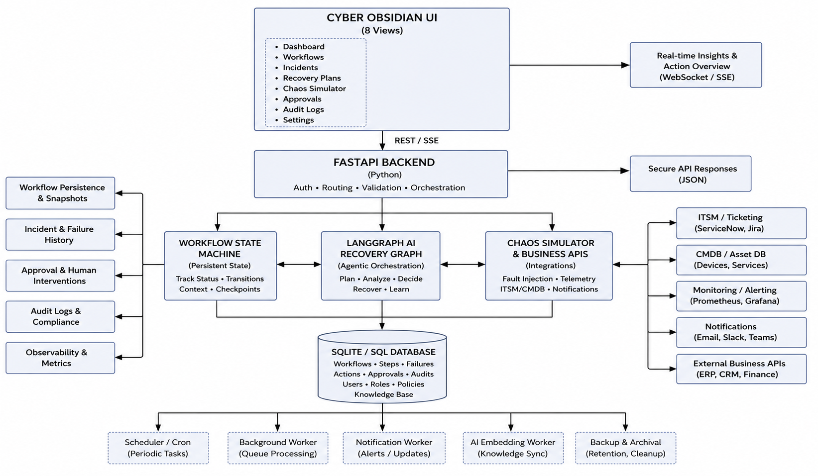

Description:
The application follows a four-layer architecture. The frontend is a vanilla HTML5, CSS3, and modular JavaScript single-page application (no build step) rendering eight operational views — Command Center, Order Workflows, Incident & Error Logs, Human Approval Gate, AI Audit Timeline, Services & Chaos Studio, AI Engine Settings, and a Workflow Timeline Inspector — all communicating with the backend over REST/JSON and a live SSE stream. The FastAPI backend exposes this API under the /api prefix, validates every payload with Pydantic v2 schemas, and enforces CORS before any request reaches the workflow engine.
Underneath the API sits the Workflow Engine, a deterministic five-step state machine (ORDER_CREATED → PAYMENT_PROCESSING → INVENTORY_CHECK → ORDER_CONFIRMATION → DELIVERY_SCHEDULING) that drives each simulated order through the Business APIs layer — independent payment, inventory, order, delivery, and notification microservices, each with its own fault-injection hooks. When a step fails, control passes to the LangGraph Recovery Graph, a compiled StateGraph of seven nodes (monitor_workflow, detect_failure, analyze_failure, create_recovery_plan, check_approval_required, execute_action, verify_recovery) with conditional edges for the human-approval gate and the verification retry loop. All state is persisted through SQLAlchemy models to a SQLite database (recovery_agent.db), and every state transition is broadcast to connected clients through the Server-Sent Events subscriber queue.

Pre-requisites:
- Python Programming Proficiency: Python Documentation
- FastAPI & Pydantic Familiarity: FastAPI Documentation
- LangGraph / Agent Orchestration Concepts: LangGraph Documentation
- SQLAlchemy ORM Basics: SQLAlchemy Documentation
- HTML5, CSS3 & Modular JavaScript: MDN Web Docs
- Server-Sent Events (SSE): MDN SSE Guide
- Version Control with Git: Git Documentation

Project Workflow:

Milestone 1: Model Selection and Architecture
- Activity 1.1: Configure environment secrets (.env) and select the AI reasoning provider.
- Activity 1.2: Research and select the LangGraph state-machine and heuristic-fallback design for autonomous recovery.
- Activity 1.3: Define the architecture of the application, detailing interactions between the frontend, FastAPI backend, workflow engine, and LangGraph agent.
- Activity 1.4: Set up the development environment, installing backend dependencies and preparing the SQLite database.

Milestone 2: Core Functionalities Development
- Activity 2.1: Develop the core functionalities: Workflow Engine, Business APIs, Recovery Tools, Approval Gate, and Audit Logging.
- Activity 2.2: Implement the FastAPI backend to manage routing, data validation, and the simulated business microservices.

Milestone 3: App.py Development
- Activity 3.1: Write the main application logic in main.py, establishing the FastAPI instance, lifespan startup, middleware, and API routers.

Milestone 4: Frontend Development
- Activity 4.1: Design and develop the Cyber Obsidian mission-control user interface using HTML, CSS, and modular JavaScript.
- Activity 4.2: Create dynamic data fetching and real-time rendering that connects every view to the live FastAPI backend and SSE stream.

Milestone 5: Deployment
- Activity 5.1: Prepare the application for local deployment by configuring the server environment and ensuring all dependencies are correctly installed.
- Activity 5.2: Deploy the application publicly using Ngrok

Milestone 6: Conclusion

Milestone 1: Model Selection and Architecture
In this milestone, the focus is on selecting the right recovery-orchestration approach for autonomous business workflow healing and defining the project's overall system architecture. This involves evaluating how a LangGraph state machine and a controlled tool registry can work together to keep every automated decision safe and traceable, and ensuring the chosen design aligns with the project's goal of self-healing failed order workflows without ever letting the AI take an unchecked, risky action.

Activity 1.1: Configure Environment Secrets and API Credentials
Before the agent can reach an external LLM provider (or run entirely offline), the project needs a set of environment secrets. Follow the steps below to set them up.
- Step 1 — Copy the Environment Template: Duplicate .env.example into a new .env file at the project root.
cp .env.example .env
- Step 2 — Choose the AI Reasoning Provider: Set LLM_PROVIDER to "heuristic" for the built-in deterministic engine (default, no key needed), or "openai", "gemini", or "anthropic" once an API key is available.
- Step 3 — Configure the Database and Server: DATABASE_URL points to the local SQLite file, while HOST and PORT control where uvicorn serves the application.
- Step 4 — Tune the Recovery Engine Rules: AUTO_RECOVERY_ENABLED, MAX_RECOVERY_RETRIES, APPROVAL_SEVERITY_THRESHOLD, and REQUIRE_APPROVAL_FOR_REPLACEMENTS govern when the agent may act autonomously versus when it must wait for a human.
PORT=8000
HOST=127.0.0.1
DEBUG=True

DATABASE_URL=sqlite:///./recovery_agent.db

LLM_PROVIDER=heuristic
LLM_MODEL=gpt-4o-mini
LLM_API_KEY=

AUTO_RECOVERY_ENABLED=True
MAX_RECOVERY_RETRIES=3
APPROVAL_SEVERITY_THRESHOLD=MEDIUM
REQUIRE_APPROVAL_FOR_REPLACEMENTS=True
CHAOS_MODE_ENABLED=False

- Step 5 — Verify the Settings Load Automatically: config.py loads every value at startup using pydantic-settings, so the FastAPI application, the LangGraph agent, and the workflow engine all read from a single Settings singleton.
class Settings(BaseSettings):
PROJECT_NAME: str = "AI Process Recovery Agent – LangGraph – Human-in-the-Loop"
LLM_PROVIDER: str = "heuristic"
AUTO_RECOVERY_ENABLED: bool = True
MAX_RECOVERY_RETRIES: int = 3

class Config:
env_file = ".env"
extra = "allow"

settings = Settings()

- Important — Never Commit Secrets: Keep .env listed in .gitignore so credentials are never pushed to a public repository.

Activity 1.2: Research and Select the Orchestration Approach
- Understand the Project Requirements: Review the system's needs — intercepting failed order steps, diagnosing root cause, and safely recovering the workflow without human oversight for low-risk actions.
- Explore LangGraph's State-Machine Model: Examine how a compiled StateGraph with explicit nodes and conditional edges gives full visibility into every automated recovery decision.
- Evaluate a Controlled Tool Registry: Assess a fixed set of twelve verified recovery tools (retry_payment, check_inventory, find_alternative_product, update_order, find_alternate_delivery, cancel_order, and their verification counterparts) as the only actions the LLM is ever allowed to invoke, so the agent can never run arbitrary code.
- Select the Orchestration Design: Adopt a seven-node LangGraph — monitor_workflow → detect_failure → analyze_failure → create_recovery_plan → check_approval_required → execute_action → verify_recovery — with a conditional branch to a Human Approval Gate and a conditional retry loop back to analyze_failure on failed verification, up to MAX_RECOVERY_RETRIES.

Activity 1.3: Define the Architecture of the Application
- Draft an Architectural Diagram: Create a visual representation of the four layers — the frontend UI, FastAPI backend, Workflow Engine / LangGraph Recovery Graph, and the SQL database — as shown above.
- Detail Frontend Functionality: Outline how operators interact with the app: reviewing the Command Center health ring, browsing Order Workflows, inspecting Incident & Error Logs, approving or rejecting actions in the Human Approval Gate, and injecting faults from the Chaos Studio.
- Outline Backend Responsibilities: Specify how the FastAPI backend exposes /api/workflows, /api/approvals, /api/failures, /api/recovery-actions, /api/audit-logs, /api/services, /api/demo, /api/settings, and /api/events routes, validating every request and response with Pydantic schemas.
- Describe AI Integration Points: Define how the RecoveryState TypedDict flows through the LangGraph nodes, how the LLMService performs structured Root-Cause Analysis and recovery-plan generation, and how every action with a real-world side effect is staged for approval before the AgentTools registry is allowed to execute it.

Activity 1.4: Set Up the Development Environment
- Install Python: Ensure Python 3.10+ is installed on the machine.
- Create a Virtual Environment: Isolate project dependencies using venv.
python -m venv venv
source venv/bin/activate # Windows: venv\Scripts\activate
pip install -r requirements.txt

- Backend Dependencies: requirements.txt pins fastapi, uvicorn[standard], pydantic, pydantic-settings, sqlalchemy, langchain, langchain-core, langgraph, httpx, python-dotenv, and pytest for the API, agent orchestration, and test suite.
- Set Up the Application Structure: The project is organized as backend/{agent, business_apis, database, routes, schemas, workflow_engine} and frontend/{css, js/components, js/pages}, keeping the LangGraph agent logic, simulated microservices, API routes, and UI cleanly separated.
- Database Initialization: SQLAlchemy's init_db() creates every table on startup, and seed_database() pre-populates ten realistic workflows spanning completed recoveries, active failures, and pending approvals so the UI is populated on first run.

Milestone 2: Core Functionalities Development
Milestone 2 builds out the core functional modules of the system and the FastAPI backend that powers them, turning the architecture defined in Milestone 1 into a working, data-driven recovery platform.

Activity 2.1: Develop the Core Functionalities
- Workflow Engine: A five-step order state machine (ORDER_CREATED → PAYMENT_PROCESSING → INVENTORY_CHECK → ORDER_CONFIRMATION → DELIVERY_SCHEDULING) built on the WorkflowEngine class, which creates, runs, and recovers workflows and persists every step through SQLAlchemy models.
- Simulated Business Microservices: Independent payment, inventory, order, delivery, and notification services under /api/business/*, each capable of having a fault injected (timeout, decline, HTTP 503, carrier disconnect) through a shared business_state singleton.
- LangGraph Recovery Agent: A RecoveryState-driven graph that performs Root-Cause Analysis, generates a discrete recovery plan, and invokes a controlled AgentTools registry of twelve deterministic tools — never arbitrary code.
- Human Approval Gate: An approvals table and API that stages any recovery action carrying business risk (product substitution, high-value transactions) and only allows execution after an operator clicks Approve.
- Failure & Recovery Action Tracking: Failure and RecoveryAction models capturing failure_type, error_code, root_cause, severity, and the tool_name and parameters selected for remediation.
- Audit Logging: An AuditLog model recording every event_type (FAILURE_DETECTED, ROOT_CAUSE_IDENTIFIED, RECOVERY_PLAN_CREATED, APPROVAL_REQUESTED, RECOVERY_ACTION_EXECUTED, RECOVERY_VERIFIED, WORKFLOW_COMPLETED) with actor, message, and a JSON details payload for full auditability.
- Chaos Engineering Studio: A fault-injection API (/api/services/chaos/inject and /reset) that lets an operator simulate payment timeouts, inventory depletion, HTTP 503 outages, and carrier disconnects on demand to trigger live AI recovery.
- Real-Time Streaming: A Server-Sent Events endpoint (/api/events) broadcasting workflow, approval, and audit updates to every connected browser tab, with an automatic polling fallback in the frontend store.

Activity 2.2: Implement the FastAPI Backend
- Define Routers per Domain: Separate routers for workflows, approvals, failures, audit-logs, services, demo, settings, and events, each mounted with its own /api prefix and OpenAPI tag, plus a parallel set of routers for the simulated business APIs.
- Validate Data with Pydantic Schemas: Every request and response is typed against the models in schemas/schemas.py — including RootCauseAnalysis, RecoveryPlan, and RecoveryPlanStep — so malformed payloads are rejected automatically and the interactive API docs stay accurate.
- Build the Controlled Tool Registry: Implement the AgentTools class as a static-method registry exposing check_payment_status, retry_payment, check_inventory, find_alternative_product, update_order, cancel_order, schedule_delivery, find_alternate_delivery, send_notification, verify_payment, verify_inventory, and verify_order.
class AgentTools:
"""Controlled tool suite for the AI Recovery Agent. The LLM never runs
arbitrary shell or raw API code; it selects and invokes these
predefined, verified business recovery tools."""

@staticmethod
def check_inventory(product_id: str) -> Dict[str, Any]:
prod = business_state.products[product_id]
is_avail = prod["stock_quantity"] > 0
return {
"success": True, "available": is_avail,
"stock_quantity": prod["stock_quantity"],
"message": f"Product has {prod['stock_quantity']} units in stock."
}

- Enforce CORS and Safety Guardrails: main.py registers CORSMiddleware so the static frontend can call the API, and every mutating recovery action routes through the Approval Gate's approve/reject flow before the AgentTools registry is allowed to execute it.

Milestone 3: App.py Development
Milestone 3 focuses on the application entry point that serves as the backbone of the backend — backend/main.py. In this milestone, the FastAPI instance is created, the database lifespan is wired in, every router is registered, and the static frontend is mounted.

Activity 3.1: Writing the Main Application Logic in main.py
- Instantiate the FastAPI Application with a Lifespan Handler: main.py creates the FastAPI() app using values from settings.py, and an async lifespan context manager initializes the database schema and seeds sample workflows on startup.
@asynccontextmanager
async def lifespan(app: FastAPI):
init_db()
db = SessionLocal()
try:
seed_database(db)
finally:
db.close()
yield

app = FastAPI(
title=settings.PROJECT_NAME,
version=settings.VERSION,
description="Autonomous Business Workflow Recovery System powered by
LangGraph AI Agent with Light 3D SaaS Interface.",
lifespan=lifespan
)

- Register CORS Middleware and Every Router: The eight core routers (workflows, approvals, failures, audit-logs, services, demo, settings, events) and the five business-API routers (payment, inventory, order, delivery, notification) are all included on the app instance.
app.add_middleware(
CORSMiddleware,
allow_origins=["*"], allow_credentials=True,
allow_methods=["*"], allow_headers=["*"],
)

app.include_router(workflows_router)
app.include_router(approvals_router)
app.include_router(payment_router)
app.include_router(inventory_router)
# ...remaining routers

- Serve the Static Frontend: The frontend directory is mounted at /static, and the root route (/) returns index.html directly so the entire single-page application is served from the same FastAPI process as the API.
- Trigger a Full Recovery Run: POST /api/workflows/{workflow_id}/recover invokes the workflow engine's approve_recovery / run_workflow logic, which drives the compiled LangGraph recovery_graph end-to-end and returns the updated workflow.
@router.post("/{workflow_id}/recover", response_model=WorkflowDetailOut)
def recover_workflow(workflow_id: str, db: Session = Depends(get_db)):
return workflow_engine.run_workflow(db, workflow_id)

- Approve or Reject Staged Actions: POST /api/approvals/{approval_id}/approve dispatches the underlying AgentTools call only after the operator approves it; /reject cancels the recovery action and marks the workflow accordingly.
- Automatic API Documentation: Because every route declares a Pydantic response_model, FastAPI generates a live, interactive Swagger UI at /docs with zero extra configuration.

Milestone 4: Frontend Development
Milestone 4 focuses on building the distinctive "Cyber Obsidian" mission-control interface — a dark, high-tech command deck built with plain HTML5, CSS3, and modular JavaScript (no framework or build step) — and wiring every one of its eight views to live data from the FastAPI backend.

Activity 4.1: Designing and Developing the User Interface
- Set Up the Base Application Shell: index.html renders a persistent floating sidebar with seven navigation tabs — Command Center, Order Workflows, Incident & Error Logs, Human Approval Gate, AI Audit Timeline, Services & Chaos Studio, and AI Engine Settings — and app.js swaps the active view into #view-container based on the selected tab.
- Establish the Visual Language: design-system.css defines the dark "Cyber Obsidian" palette and glassmorphic 3D card tokens, while layout.css and components.css style the sidebar, topbar, floating cards, and workflow nodes; animations.css drives the orb-pulse, energy-route, and node-glow keyframes.
- Build the AI Orb and Health Ring: aiOrb.js renders a reactive AI status indicator that reflects whether the agent is monitoring, recovering, or awaiting approval, while healthRing.js renders a segmented SVG ring summarizing overall workflow health on the Command Center.
- Build the Workflow Map and Timeline: workflowMap.js renders an interactive live map of active workflows and their current step, and workflowTimeline.js renders a branched recovery timeline for a single workflow's detail view, visualizing the LangGraph node sequence it passed through.
- Compose Page-Specific Views: dashboard.js (Command Center with quick-launch demo scenario pills), workflows.js (Order Workflows explorer), workflowDetail.js (Workflow Timeline Inspector), failures.js (Incident & Error Logs), approvals.js (Human Approval Gate), audit.js (AI Audit Timeline), services.js (Business Services & Chaos Studio), and settings.js (AI Engine Settings) each render one operational view from the shared store state.
- Add the Demo Scenario Selector: A topbar dropdown lets the operator launch any of the five pre-packaged end-to-end recovery scenarios (stock depletion, payment timeout, service outage, courier disconnect, and high-value review) directly from the UI.

Activity 4.2: Creating Dynamic Content Rendering
- Centralize API Calls: api.js wraps every backend endpoint (workflows, approvals, failures, recovery-actions, audit-logs, services, demo, settings) behind typed fetch functions the page modules call directly.
- Maintain a Reactive Central Store: store.js holds the application's shared state (workflows, approvals, audit logs, service health, settings) and notifies subscribed pages to re-render whenever new data arrives.
- Stream Live Updates over SSE: The frontend subscribes to /api/events via EventSource for zero-latency updates when the agent detects a failure, requests approval, or completes a recovery, with an automatic polling fallback if the SSE connection drops.
const es = new EventSource('/api/events');
es.onmessage = (evt) => {
const data = JSON.parse(evt.data);
store.dispatch(data.type, data.payload);
};

- Run Recovery Scenarios from the UI: The "Run Demo" button in the topbar calls /api/demo/run-scenario, then refreshes the workflow list, health ring, and Agent Trace so the LangGraph state machine's progress is visible immediately.
- Enforce Human-in-the-Loop Safety in the UI: The Human Approval Gate renders every pending approval with Approve and Reject buttons; approving calls /api/approvals/{id}/approve, which only then dispatches the underlying recovery tool and updates the workflow view in real time.
- Format Currency Consistently: A shared formatINR helper in store.js formats every order total and workflow amount in Indian Rupee notation across the Command Center, Order Workflows, and Approval Gate views.

Milestone 5: Deployment
In Milestone 5, the focus is on deploying the application first locally to verify correct operation, and then publicly via Ngrok to share the app over a secure, accessible URL. This involves configuring the server environment, managing dependencies, and launching the app for real-world use.

Activity 5.1: Preparing the Application for Local Deployment
Set Up a Virtual Environment:
- Open a New Terminal
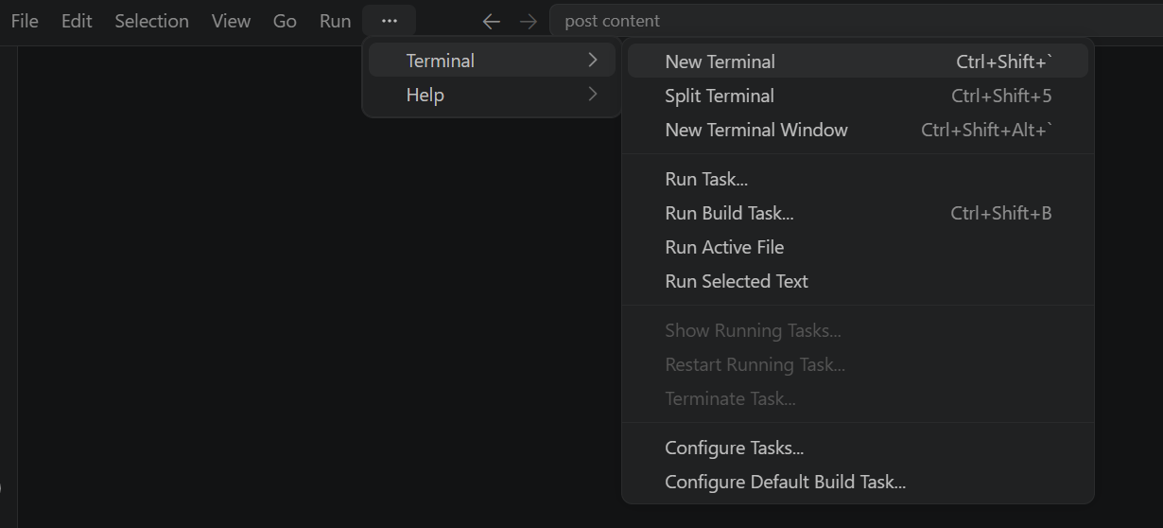
- Then open “Command Prompt”
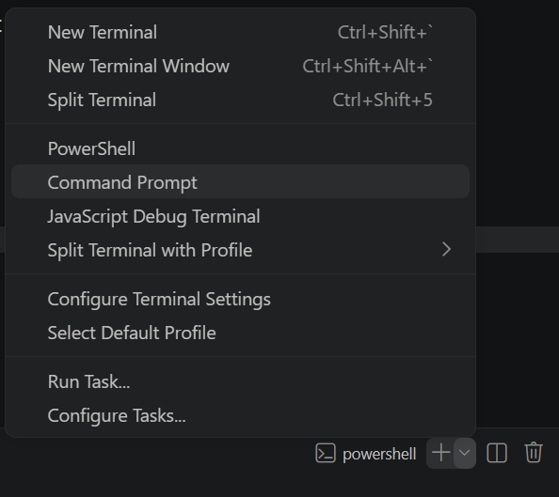

- Create and activate a virtual environment, then install all required dependencies from requirements.
D:\projects>python -m venv myenv
D:\projects>"d:\projects\venv\Scripts\activate"
(myenv) D:\projects>pip install -r requirements.txt

Configure Environment Variables:
- Create a .env file in the project root and add your Groq API key. The app loads this automatically using python-dotenv at startup:
GROQ_API_KEY=your_groq_api_key_here

Activity 5.2: Public Deployment via Ngrok
Ngrok creates a secure tunnel from a public URL to your local FastAPIserver, making the app accessible from anywhere without a cloud hosting provider.
Install Ngrok and pyngrok:
- Install the pyngrok Python wrapper, which manages Ngrok programmatically within your Python project:
pip install pyngrok
- Download and install the Ngrok client from https://ngrok.com/download.
- Click on “Microsoft Store Installer”.
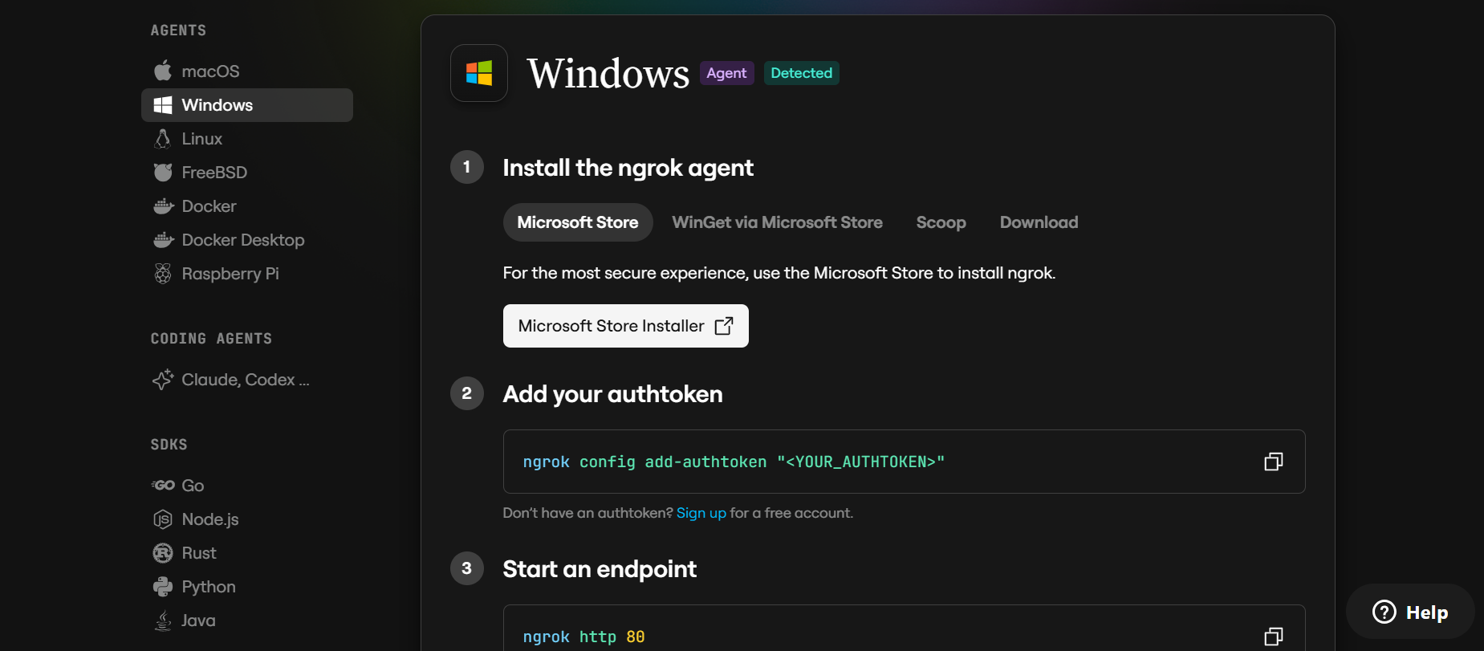
Configure Your Ngrok Authtoken:
- Sign up at ngrok.com and copy your authtoken from the Ngrok dashboard.
- The run_public.py script sets the authtoken automatically using:
D:\projects>ngrok.set_auth_token("YOUR_NGROK_AUTHTOKEN")
- Replace the TOKEN value in run_public.py with your own Ngrok authtoken before running.

Run the Public Deployment Script:
- Instead of running app.py directly, launch run_public.py to start both the Ngrok tunnel and the Flask server:
D:\projects>python run_public.py
- The script opens an HTTP tunnel on port 5000 and prints the live public URL in the terminal:
======================================================
YOUR PUBLIC WEBSITE URL IS LIVE!
URL: https://xxxx-xx-xx-xxx-xx.ngrok-free.app
======================================================
- Share this URL with anyone who can access your CaptionAI app directly from their browser without any installation.

Important Notes:
- debug=False is required in run_public.py to prevent Flask from spawning a reloader process, which would interfere with Ngrok’s tunnel management.
- The public URL changes each time you restart run_public.py (on the free Ngrok plan). For a persistent URL, upgrade to a paid Ngrok plan and configure a reserved domain.
- Ngrok free tier sessions expire after a few hours of inactivity. Restart run_public.py to get a new URL when this happens.

Exploring Web Pages:

Command Center:
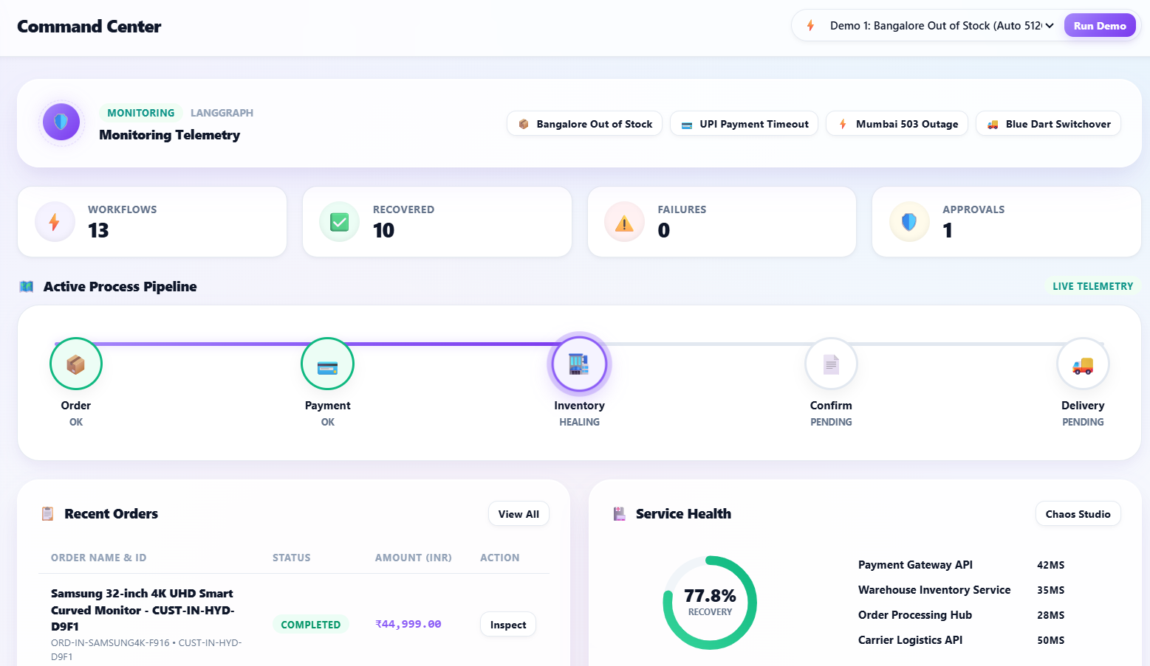
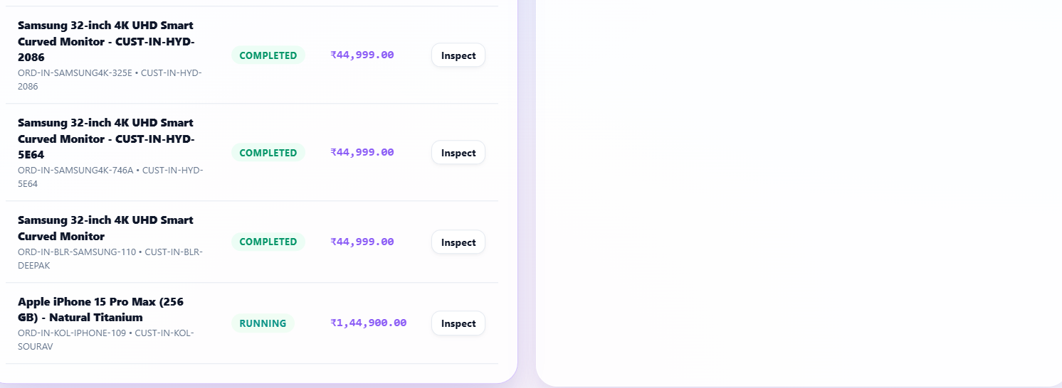

Description: The default landing view and the application's mission-control home. It opens with the reactive AI Orb and quick-launch scenario pills, alongside a segmented Health Ring summarizing overall workflow health and a live feed of the most recent order workflows and their current step.

Order Workflows:
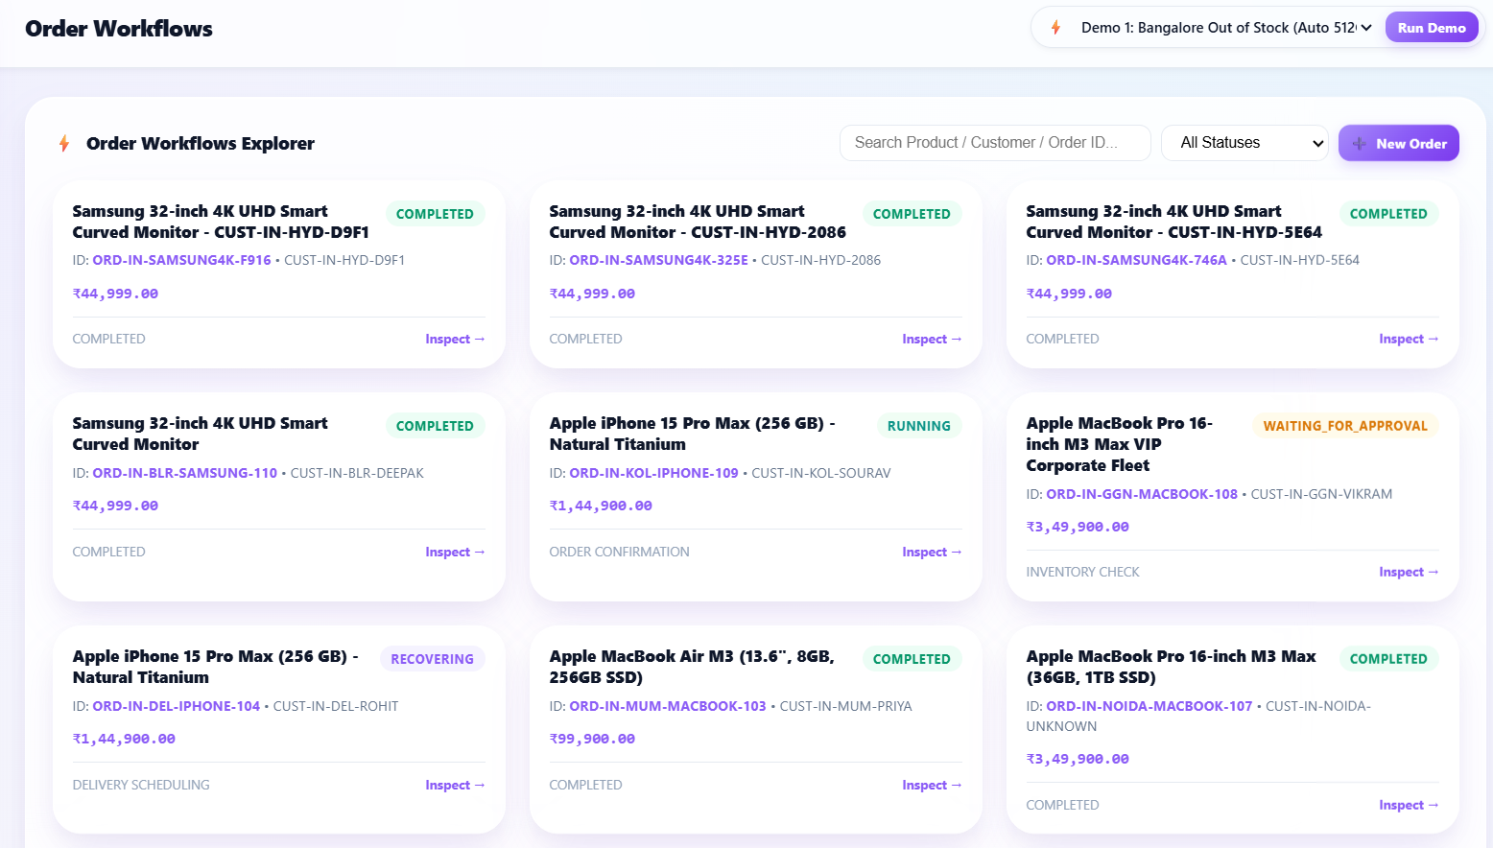

Description: A searchable explorer listing every simulated order workflow with its order name, customer, current step, status, and total amount (formatted in ₹). Selecting a workflow opens the Workflow Timeline Inspector, which renders the branched recovery timeline for that order.

Incident & Error Logs:
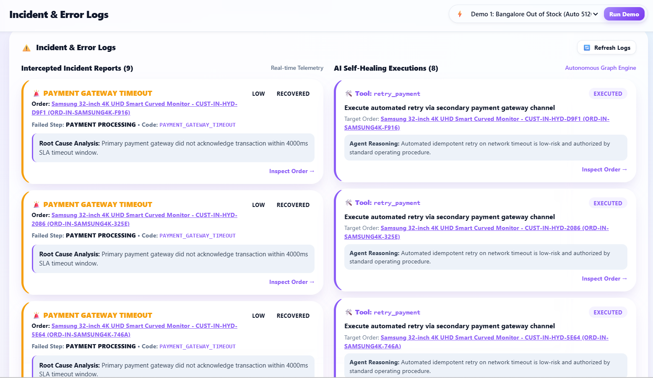
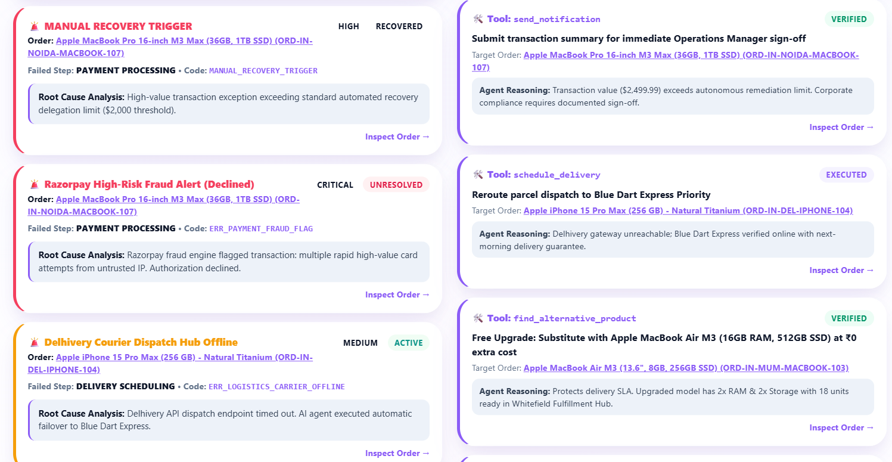
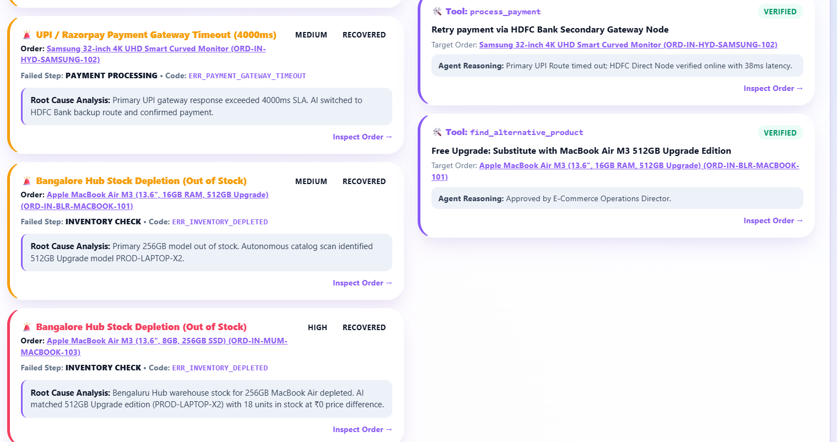

Description: A log of every intercepted failure — stock depletion, payment gateway timeouts, warehouse 503 outages, courier disconnects, and high-value security reviews — each annotated with its failure type, error code, root cause, and severity, plus the recovery action the agent proposed in response.

Human Approval Gate:
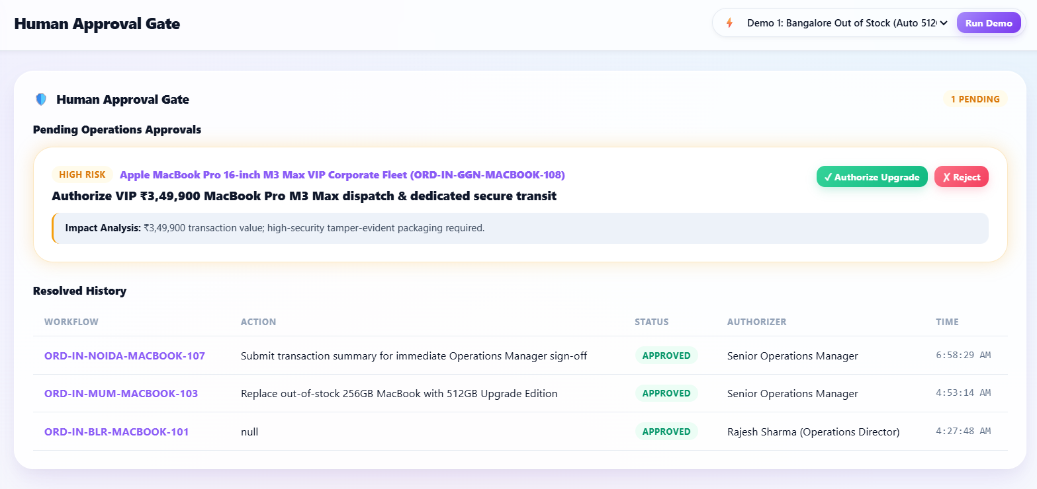
Description: The central human-in-the-loop approval center. Every recovery action the agent proposes with business risk — a product substitution or a high-value transaction — is staged here with its risk level, reasoning, and impact summary, and only executes once the operator clicks Approve; Reject cancels it without any side effect being dispatched.

AI Audit Timeline:
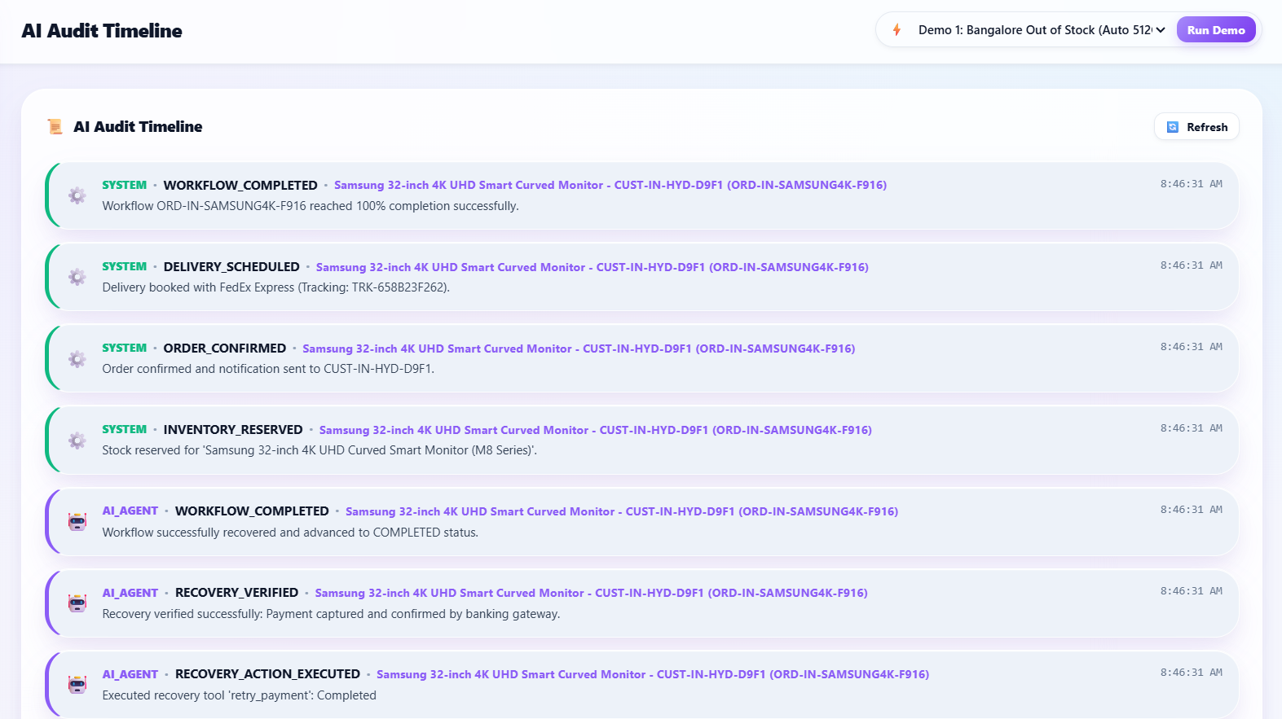
Description: A chronological, event-by-event audit log of every workflow's recovery lifecycle: FAILURE_DETECTED, ROOT_CAUSE_IDENTIFIED, RECOVERY_PLAN_CREATED, APPROVAL_REQUESTED, RECOVERY_ACTION_EXECUTED, RECOVERY_VERIFIED, and WORKFLOW_COMPLETED, each entry recording the actor, message, and full JSON detail payload for complete transparency.

Services & Chaos Studio:
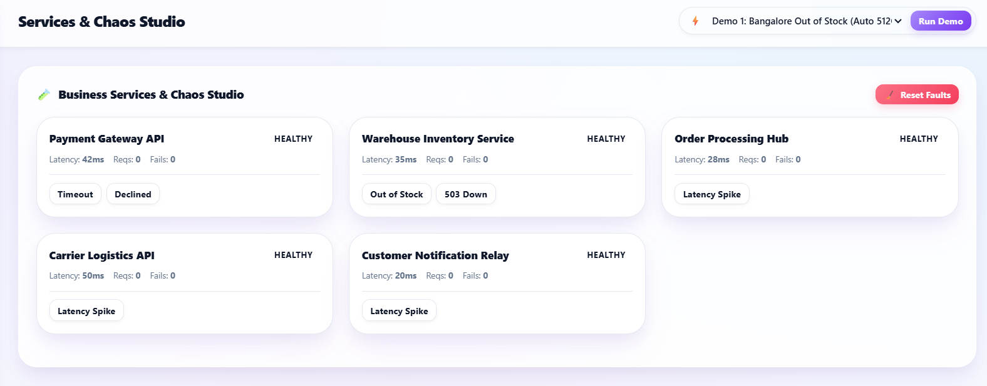
Description: A live health dashboard for the five simulated business microservices (payment, inventory, order, delivery, notification), paired with a Chaos Engineering control center that lets the operator inject payment timeouts, stock depletion, HTTP 503 outages, or carrier disconnects on demand — and reset every fault with a single click — to trigger and observe live AI recovery.

AI Engine Settings:
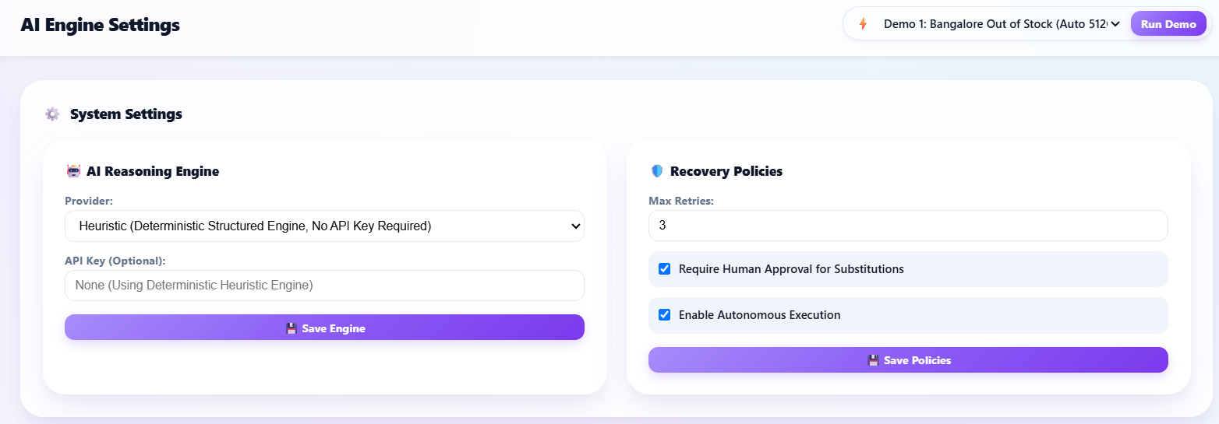

Description: A configuration view for the AI Reasoning Engine and recovery-policy parameters — switching between the heuristic engine and an external LLM provider, and adjusting auto-recovery, retry limits, and the approval-severity threshold that decides which actions require human sign-off.

Conclusion:
The AI Process Recovery Agent is an autonomous business workflow recovery system built with FastAPI, SQLAlchemy, and a LangGraph agentic recovery graph connected to a controlled registry of business recovery tools. It turns a failed step in an e-commerce order — a stock-out, a payment timeout, an infrastructure outage, or a courier disconnect — into a self-healed, completed order, while keeping every automated decision auditable through the AI Audit Timeline and every risky action gated behind explicit human approval in the Human Approval Gate.
The project, which spanned recovery-orchestration and architecture design, backend and controlled tool-registry development, a Chaos Engineering fault-injection studio, and a real-time mission-control frontend, demonstrates how a deterministic, well-traced LangGraph recovery workflow combined with a human-in-the-loop safety boundary can automate real operational toil without sacrificing operator trust. Looking ahead, the platform is positioned to grow from its current in-memory business-API simulation into a system wired to genuine payment, warehouse, and logistics providers, to layer in live LLM-backed reasoning as the default recovery engine, and to extend the controlled tool registry to additional business domains beyond order fulfillment — evolving it from a demo-ready prototype into a genuinely production-grade autonomous recovery platform.

